BoC CYPRUS SITE SPECS

As a general note the site should be responsive and all images / text should be adjusted according to device used. Especially for images we need your advice if for example we will load 3 images one for mobile, one for desktop, etc.

- homepage-boc.html (homepage)

1.1 HEADER

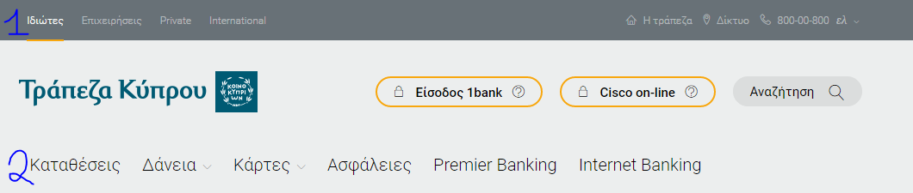

- First level navigation on top (marked as 1), user can select Personal, Business Private, etc
- 3 links on top right should be CMS manageable (tel no. to be able to input it)
- Logo on the left should be managed through CMS
- 1Bank and Cisco Online should be both linked to external links (Edited through CMS)
- Search should provide results to a results page
- Site languages: Greek English Russian and Chinese

1.2 MEGA MENU (Second level navigation (marked as 2))

Second level navigation should be based on mega menu concept as demonstrated in the HTML. Content structure created in CMS should reflect in the Mega Menu

It should have the option to add image/content left of the menu and links at the bottom

Breadcrumb navigation should appear on all pages

1.2 Maintenance Message

Should appear only if scheduled (time and date) and should display a short message

1.4 CONTENT AREA (Banners)

This area should be dynamic and constructed as a CONTENT AREA to allow an editor to add or remove BLOCKS. In the submitted HTML there are 4 areas but we may have more than 4 areas:
These blocks should be reusable in all top level navigation pages (Personal Business, etc)
- A banner with content and action button on the right (Image, Content and action button should be CMS Manageable)
- A banner with content and action button on the left (Image, Content and action button should be CMS Manageable)
- A banner with content (Bullet type)and action button on the left (Image, Content and action button should be CMS Manageable)
- A carousel as presented in the HTML (Title Subtitle Categories, images, image content manageable through CMS

1.5 FOOTER

Footer should be dynamic.

Categories should be dynamic and specified by editors which are the most important categories /subcategories to be displayed.

Bottom links and social buttons should edited through CMS

Newsletter is not in use, remove it.

2. homepage-boc-promo.html

A promo banner appearing on the top of the screen if scheduled (time and date). Image content should be CMS manageable.

User should have the option to close it (X)

We could have more than one so arrows on left and right acts as navigation

3. homepage-corporate.html

This is the homepage of a top level navigation option in this case the Corporate

4 main areas are displayed in the content area . These blocks should be reusable in all top level navigation pages (Personal Business, etc)

- Title / Subtitle, image on the left and content on the right
- A banner with content and action button on the right (Image, Content and action button should be CMS Manageable)
- A banner with content and action button on the left (Image, Content and action button should be CMS Manageable)

4. ebanking.html

This is a homepage of a second level navigation in this case Internet Banking under personal. Areas are:

4.1 Main banner with content and action button
4.2 Title / Subtitle
4.3 Main Advantages area
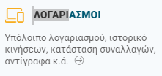
Image, title, short content and links are CMS manageable

4.4 Banners area
Title/Subtitle
Square Banners (should include title / image/ short description and link)
Larger Banner ( Title / Content/link on the left and image on the right)

4.5 Area on the right

There are 4 areas (1 link to a form, 2 video, 3 links, 4 Contact us)

These should be created as blocks

5. cards_ver1.html

This is another homepage of a second level navigation, in this case for Cards under personal. Areas are:

Large Banner Area. 3 large banners on top. One of which on click displays a video. Others are the same as described above

Small Banners area
Title/Subtitle
Square Banners (should include title / image/ short description and link)

Area on the right

There are 4 areas
- link to a tool (not supplied in the HTMLs) Image, content and link should be CMS editable,
- links to pages ,
- Useful links,
- Contact us

These should be created as blocks

6. cards_inside.html

This is a 3rd navigation level sample template, representing a main category under Cards, ie Credit Cards

  - Main banner with content and action button

  - Blocks, 1 to many that includes title / subtitle and images of cards on the right. Below we should add cards characteristics in 3 columns as shown in the HTML. Link button should go to page with all cards of this category

  - 2 smaller banners with title subtitle on the bottom of the page linking to a card

- eke.html

This is the CSR page of the bank with pillars like Health Education, Youth etc

  - Main banner with content and action button

  - Title, Subtitle and short description

  - Banners, 1 to many that includes PILLAR, title, short description and image .

  - On the right top the, main pillars linking to each pillar page (image, link, short description)

  - On the right bottom, latest news for each pillar (pillar, news title link)

- loans-boc.html

This page a loan wizard aiming to give the user a clear image of all loan he/she is interested

The Circles on top represents filters where the user can select

Then, the table adjusts accordingly to display the loans and characteristics based on filtering below

The more button in each table row links to the loan page

CMS must accept these table values in each loan page so these are automatically represented in this table

- loan.html

This is a product page for loans and other product pages

- Title and short description
- Area with product characteristics (1 to many, according to available page space), Image, title and short description
- Accordion with product details
- On the right, two blocks one for Branch locator (link) and Loan calculator (formulas to be provided)
- Bottom banner with image title subtitle

10 . loan-calculator.html

This is a loan calculator pages with one or more calculators (Tabs)

- Main banner with content and action button
- Calculator Tabs
- Calculators - formulas to be provided by the Bank
- Disclaimers (1 to many)

- stores.html

This is the Branch/ATM locator page. Branches list will be loaded from an excel files as the procedure today

Page will use the Google API to display the Branches

- User can select to search a branch from the search field (search by town, branch name, area, etc)
- Sort results by categories, ie ATMs only

- search.html

Search results Page. Results are sorted by first level categories ie Personal (11)
Results to be grouped by page, ie page 1 of 10

- search-noresults.html

If no results we need to define a text to show
- faq.html

An FAQ page with categories represented as TABS.

One Category can have many subcategories and under that we have the questions organized as accordions

There a search field to search only in FAQ section

On the left there are blocks for
- the Main FAQ categories as links
- Useful information links
- And contact info

- currency.html

The content for currency page will be loaded with the same procedure used today on the existing site

- Image banner on to
- Title / subtitle
- Currency Calculator (you can reuse the formula from existing site)
- Currency table
- Disclaimer (set by CMS Editor)

- documents-boc.html

This is general document list for PDFs

Page Title
Sort by year
Document (Image / Date /Title) – Sorted latest document first

- contact-boc.html

This is the Contact us page

Editors should edit the Tile , subtitle, main contact details below and right column

The form should be created with the fields shown in the design

Form should be created based in EPiServer Forms functionality

CAPTCHA is required

18. iban-calculator.html

This is the IBAN calculator you can take the formula from existing web site

19 promo-inner.html

This page will serve a number of different campaigns and purpose is to replace the micro sites we have today

For example, a promo page will act as the landing page of a new credit card

This template has 5 areas (blocks) to be used accordingly. All areas must be customized by the editors.

Blocks to be created are as shown in the HTML

In the future we may ask for more blocks for this

20 promo-inner-video.html

This adds a video on top of a promo page

21. General purpose product page

We don’t have an HTML for this but we need a template for product pages. (Add images and text through the CMS Editor)

